MAJOR EXHIBITION OF BRITISH PHOTOGRAPHY OPENING AT SESI-SP ART GALLERY ON THE 25TH

The exhibition “Observers: Photographers of the British Scene from the 1930s to Now” a partnership between SESI-SP and the British Council, reveals in 240 images by 36 photographers images of Britain’s society, culture, places and people from the last 80 years.

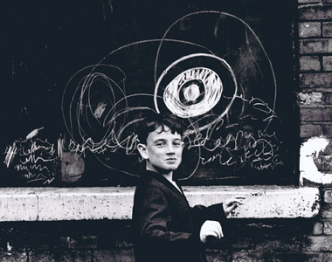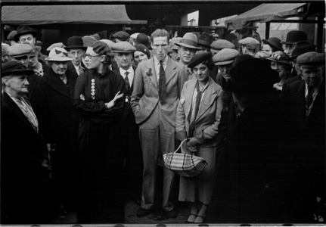
Shirley Baker - Cheeky Young Graffiti artist, Manchester, 1967 (1), Humphrey Spender - Open market - shoppers, 1937-1938 (2)

SESI-SP Art Gallery at FIESP Cultural Center – Ruth Cardoso, presents from 25th September to 25th November 2012 the exhibition: “Observers: Photographers of the British Scene from the 1930s to Now”. A partnership between SESI-SP and the British Council, this is the first and largest show presented in Latin America of British photography of the last 80 years.

Curated by João Kulcsár and Martin Caiger-Smith, the exhibition covers the new photographic directions of the 30s up to the present day. The exhibition includes 240 images selected from collections such as the National Portrait Gallery, British Council, the Arts Council and private collections – by 36 photographers who turned their lenses onto the culture, customs and people of Great Britain.
Observers focuses on the tradition of documentary practice present in photography produced in the UK, and reveals nearly a century of British scenes with images captured in the analogue universe and in the digital era, depicting an age that saw the birth of television, talking pictures and the mass circulation of newspapers and magazines.
The exhibited works range from the urban scene to high society, through to the bold and subversive realism of British street culture. Among the influential photographers who assumed the role of voyeur in their home country, either by birth or long stay, are Bill Brandt, Martin Parr, Wolfgang Tillmans, Cecil Beaton, George Rodger, Richard Billingham, Derek Ridgers, Tony Ray-Jones, Daniel Meadows, Chris Killip, Paul Nash and Keith Arnatt.
The exhibition title is inspired by the Mass Observation project, created in 1937 by the anthropologist Tom Harrisson, the poet Charles Madge and by the film maker Humphrey Jennings. The proposal was to examine and document the way the English working class lived, through their habits and customs. In the interwar period, the creators of Mass Observation realised that there was a difference between what was known and the real life of the ordinary people of England.
This created an opportunity for artists, anthropologists and sociologists to work together creatively to develop the best way to understand what people were actually doing in Britain.
“Observers: Photographers of the British Scene from the 1930s to Now” is a partnership between SESI-SP and the British Council, and is part of the UK Season - a programme of cultural and educational activities from the UK in Brazil, which runs from September 2012 to March 2013.

About the curators:

João Kulcsár – Master of Arts from the Kent University, Canterbury, UK, with a British Council scholarship, Kulcsár was a visiting professor at Harvard University, EUA, by the Fullbright Commission. SENAC Coordinator of photography, and curator of photographic exhibitions in Brazil such as Claudia Andujar, Cristiano Mascaro, Maureen Bisilliat, Thomaz Farkas, Lewis Hine, FSA (Walker Evans e Dorothea Lange), Magnum, Impressões Visuais (which travelled to all Brazilian capitals) and Edward Curtis exhibition. Abroad Kulcsár has curated exhibitions in Portugal, EUA, Cuba, Italy and Switzerland. He is the editor of the site www.alfabetizacaovisual.com.br.

Martin Caiger-Smith – Studied History and History of Art at Cambridge, and has an MA from the Courtauld Institute. Currently the Head of MA Programme: Curating the Art Museum at the Courtauld Institute, he is a consultant on art and exhibition projects and writes on contemporary art, photography and exhibitions. He has worked in a variety of positions in UK galleries, at the Photographers’ Gallery and most recently at the Hayward Gallery in London as Head of Exhibitions and Acting Director.

SERVICE:

EXHIBITION: “Observers: Photographers of the British Scene from the 1930s to Now”
Place: Galeria de Arte do SESI-SP - Centro Cultural FIESP – Ruth Cardoso
Address.: Av. Paulista, 1.313 (Trianon-Masp subway)
Opening: Monday, 24th September at 19:30 (invite only)
Exhibition dates: 25th September to 25th November 2012
Admission times: Monday from 11:00 to 20:00; Tuesday and Saturday from 10:00 to 20:00 and Sunday from 10:00 to 19:00
Schools and groups: from Monday to Friday from 10:00 to 13:00 and from 14:00 to 17:00, please phone: 55 11 3146-7396
Free admission

About the British Council

The British Council is the United Kingdom’s international organisation for educational opportunities and cultural relations. Its work seeks to establish the exchange of experiences and create bonds through the exchange of knowledge and ideas between people around the world. It focuses on five areas: Education, English Language, Arts, Sports and Examinations. The organisation operates in 223 cities and in 109 countries, in partnership with governments and in several instances, non-governmental organisations and the private sector. The British Council has offices in Brasília, Rio de Janeiro, Recife and São Paulo.

