OR2013 ePrints User Group

UCARIS: Developing a research information system for a specialist arts institution.

In response to the Higher Education Funding Council of England (HEFCE) research quality assurance assessment exercise, the Research Excellence Framework in 2014 (REF), the University for the Creative Arts (UCA) identified a need to establish a centralised information system to gather, manage and maintain relevant data relating to its research and researchers in order to effectively prepare for the university’s REF submission.

In 2010 internal funds were secured to develop UCA Research Information System (UCARIS). The project proposed the development of a comprehensive, university wide research information system using the EPrints repository platform. As well as being seen as critical for the REF submission, the overarching approach of the implementation of UCARIS was that there should be ‘one input, many outputs’, in order to minimise the burden on academics and administrators in producing publications lists and reports for other internal and external purposes.

In preparation for the REF, the university has been working with EPrints Services to adapt the EPrints REF plugin to fit with the university’s specific requirements. It has developed an appropriate publications strategy and a research information system that will be flexible enough to return any publication data that the REF may require within the relevant units of assessment.
Since March 2009 the university has had an EPrints based institutional repository, UCA Research Online. This installation has been adapted to meet the specific needs of the visual arts researchers and their outputs. The aim of UCA Research Online is to curate, publish and preserve the research outputs created by the university’s researchers and ensure they reach the widest possible audience, to enhance the university’s reputation nationally and internationally, and to enhance its own learning, teaching, research and knowledge transfer activities.

UCA Research Online provides a self-archiving tool and platform for all research outputs produced in the institution and related data, including external funding details, collaborations and impact (through reviews, media exposure, footfall of exhibitions, and follow-on research opportunities). UCA Research Online has been enhanced and tailored by additions from other projects such as eNova, which developed the ‘look and feel’ of the online academic profiles needed both by visual researchers and for the REF submission. UCA Research Online also responds to the increasingly mandatory requirements of external funding bodies and stakeholders to provide accurate and comprehensive data on research outputs and performance.

As part of the UCARIS project, it was acknowledged that UCA Research Online was going to play a key role in the REF submission by providing content in terms of research outputs and staff profile information, neither of which was available in other institutional systems. The flexibility of EPrints to harvest data from other systems and ‘push’ processed information both back to them and on to other systems meant that the development of UCARIS would ensure the university had an appropriate research information system capable of supporting its REF submission with potential to support and grow in future to meet new challenges and opportunities.

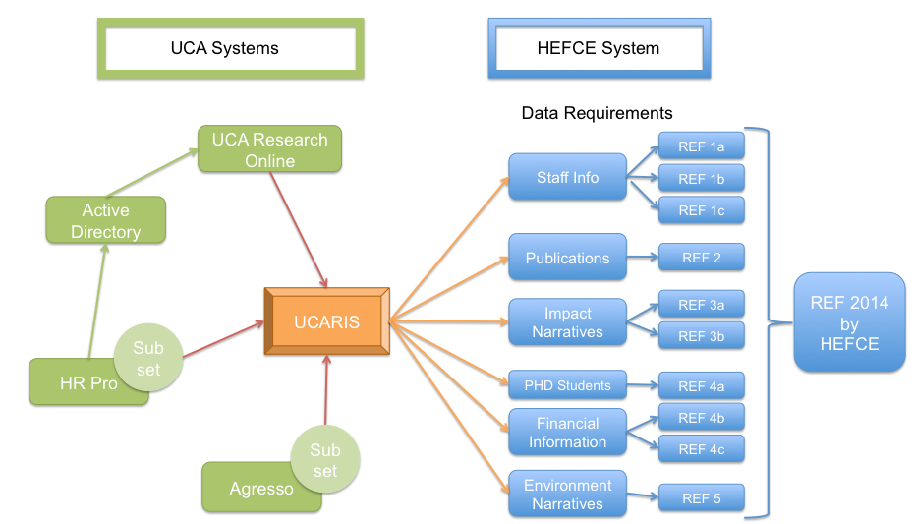
Fig. 1 UCARIS Interfaces

At the centre of UCARIS is the EPrints REF plugin (Fig. 1). Looking at the various options, the project team decided to create a separate instance of EPrints specifically to host the REF plugin and host UCARIS. This minimised the risks associated with handling confidential and researcher information on the same infrastructure as UCA Research Online, and enabled the setting up of separate permissions to add, modify and delete data, and allowed the new system to be restricted to internal access within the university only.

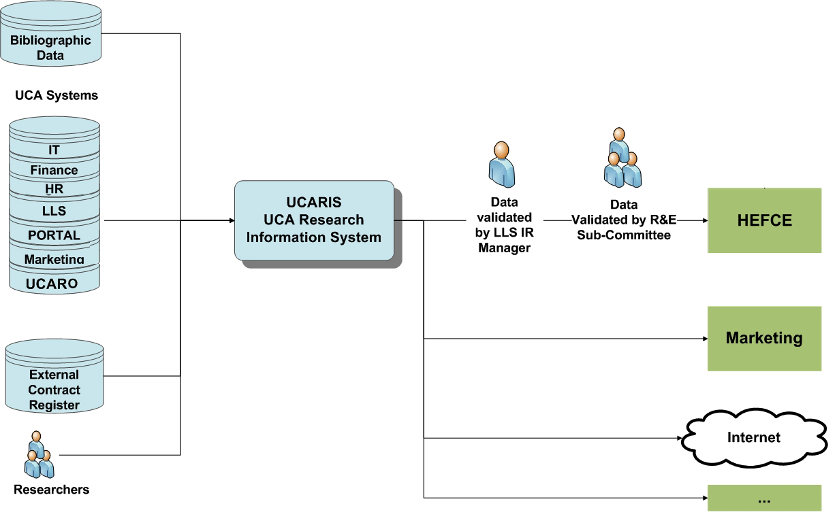
Fig. 2 UCARIS Framework

As illustrated above, the project team proposed to identify and integrate relevant university data required to be supplied to UCARIS. At the time of writing the team has achieved the integration of the EPrints REF module with key systems including the authentication system (LDAP) and the personnel database (HRPro). Data from both these systems is being fed into UCARIS. The personnel database was linked by creating an automated subset of data needed for the REF submission directly within HRPro. This was then automatically uploaded it to UCARIS system, where the data is automatically processed into the system itself on a daily basis. This data is then collated, alongside data from other sources, and UCARIS updates a number of subsets, which then feed into UCA Research Online and the REF submission system after validation by the Research Office and Repository Manager.

Future developments for UCARIS include feeding data to other internal and external university systems to support and enhance marketing, learning, teaching and knowledge transfer activities. There is further potential for integration with other systems in the future as required, using SWORD2 and OAI-PMH protocols.

