
JISC Final Report

Project Information
Project Identifier | To be completed by JISC
Project Title | Spot the Difference
Project Hashtag | spot
Start Date | 1 June 2011 | End Date | 31 May 2012
Lead Institution | University for the Creative Arts
Project Director | Leigh Garrett
Project Manager | Amy Robinson
Contact email | arobinson@ucreative.ac.uk
Partner Institutions | University of Surrey
Project Web URL | http://www.vads.ac.uk/spot
Programme Name | e-Learning Programme - Learning and Teaching Innovation Grant
Programme Manager | Rob Englebright

Document Information
Author(s) | Amy Robinson
Project Role(s) | Project Manager
Date | 21 May 2012 | Filename | spotfinalreport.doc
URL
Access | This report is for general dissemination

Document History
Version | Date | Comments
1 | 24 May 2012

Table of Contents
NB : This table of contents ‘auto-populates’ - to update the table of contents – place cursor in the table of contents, right-click your mouse, click ’update field’, select appropriate option

1 Acknowledgements 3
2 Project Summary 3
3 Main Body of Report 4
3.1 Project Outputs and Outcomes 4
3.2 How did you go about achieving your outputs / outcomes? 4
3.3 What did you learn? 10
3.4 Immediate Impact 13
3.5 Future Impact 14
4 Conclusions 14
5 Recommendations 14
6 Implications for the future 14
7 References 15

Acknowledgements

The Spot the Difference project was a collaborative venture between the University for the Creative Arts (UCA) and the University of Surrey and was funded through the JISC e-Learning programme’s learning and teaching innovation strand. We are grateful to the JISC Programme Manager, Rob Englebright, for his expert advice and support throughout the project.

The project team included: Leigh Garrett (UCA); Dr John Collomosse (University of Surrey); Amy Robinson (UCA) and Gorm Ashurst (Bullet Creative). We would like to thank the many survey respondents, interviewees, and workshop attendees, totalling in excess of 200 participants, for sparing their time and expertise to assist with the project’s research and user testing.

We are particularly grateful to the following people who also provided assistance with organising project workshops at their institutions: Jon Renyard at Arts University College at Bournemouth; Caroline Cash and Doreen Pinfold at University College Falmouth; Lindsay Jordan and John Jackson at University of the Arts London; and Annamarie McKie at University for the Creative Arts.

Project Summary

The Spot the Difference! project brought together the University for the Creative Arts and the University of Surrey in a new partnership focusing on visual plagiarism.

The project was led by the Visual Arts Data Service (VADS) based at the University for the Creative Arts, and piloted the use of visual search tools developed by the Centre for Vision, Speech, and Signal Processing (CVSSP) at the University of Surrey, and tested their application to learning and teaching in the arts, and specifically tested their application to the issue of visual plagiarism.

Whilst there has been extensive research and guidance on the issue of text-based plagiarism in universities, there has been relatively little research undertaken in the area of visual plagiarism (Blythman, Orr, and Mullin, 2007). The Spot the Difference project sought to address this gap, and in particular to explore the potential application, relevance, and impact that visual search technology may have to offer in this highly complex area.

The project had two main outputs. Firstly, the project collated the existing knowledge, experience, and perceptions of academics, learning support staff, and senior managers in the UK arts education sector surrounding the issues, nature, and extent of visual plagiarism.

Secondly, the project developed a visual search demonstrator utilising technologies developed by the CVSSP at University of Surrey. The project tested the ability to upload an image which was compared against the images hosted by VADS (vads.ac.uk). Feedback on this pilot tool (termed iTrace) was then gathered from staff and students at a selection of specialist arts institutions.

Main Body of Report

Project Outputs and Outcomes

Output / Outcome Type  (e.g. report, publication, software, knowledge built) | Brief Description and URLs (where applicable)
Environmental analysis | The project collated the existing knowledge, experience, and perceptions of staff across the UK arts education sector surrounding the nature, issues, and meaning of ‘visual plagiarism’ through interviews, an online survey, and literature review.
Visual search demonstrator (iTrace) | A pilot visual search tool that compares images that are uploaded to the system against a selection of 10,000 images hosted by the VADS image repository. This pilot tool utilises technologies pioneered by the CVSSP at University of Surrey, using the ‘bag of visual words’ (BoVW) framework:  www.itrace.ac.uk
Project blog | Project progress and findings reported on a project blog: www.vads.ac.uk/spot
Project workshops | Project workshops held at three specialist arts institutions, to test and gather feedback on the pilot visual search tool.
Dissemination | Dissemination of the project at national events and in online and printed articles in 2011/12.
Potential for future collaboration | Submission of a project funding bid to work with University College Falmouth, University of the Arts London, and University for the Creative Arts on the development of a visual plagiarism OER for early career staff (PGCHE students) and Library staff.

How did you go about achieving your outputs / outcomes?

Environmental Analysis

  - A review of the literature surrounding plagiarism in non-text based media was carried out by the Project Manager and a bibliography of resources on the topic has been made available on the project blog at: www.vads.ac.uk/spot/?page_id=89

  - An online survey was also conducted in August 2011 to elicit staff views and experiences on the subject and a total of 158 responses were received from across the UK arts higher and further education sector and several international responses were received from staff at universities in Canada and India.

  - Detailed face-to-face and telephone interviews were held with eight members of staff including academics and support staff from across four specialist arts institutions in the UK to discuss the issues surrounding ‘visual plagiarism’ in greater depth.

  - Information was also gathered through informal discussions with a number of the authors identified in the project’s literature review, including Mic Porter (Northumbria), Stephen Bowman (formerly Ravensbourne), Paul Kleiman (HEA), Shan Wareing and Lizzie Vinton (UAL).

  - The findings of this research are detailed in forthcoming conference papers and an overview is also provided in section 3.3 of this report.

Software Development

  - At the same time, technical development for the first iteration of the visual search tool (termed iTrace) was also underway. This offline Windows-based prototype was trialled with an index of sixty images from the VADS collections:

Initial Prototype

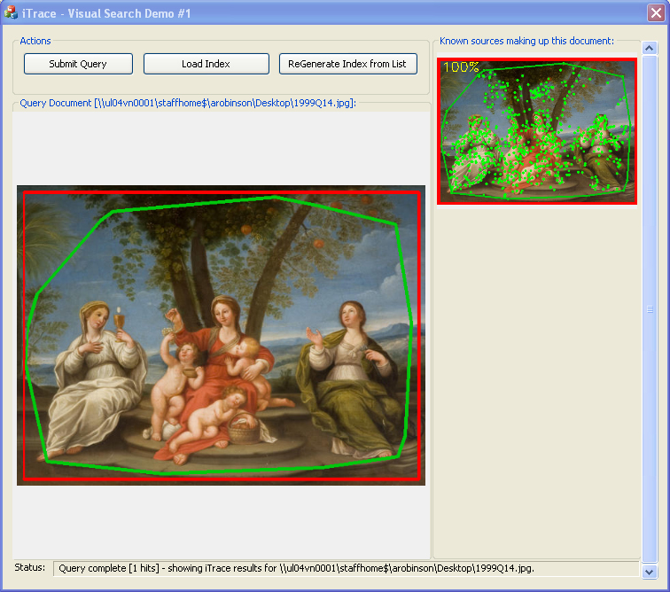
Fig. 1 Windows-based prototype (left: uploaded image; right: search results).

  - Initial user testing was conducted by the project team, and any relevant findings that were gathered during the environmental analysis stage were passed on to the technical developer at University of Surrey. The VADS team also outlined well-known user needs in the creative arts (such as the need for a highly visually appealing user interface).

  - Initial web design mock-ups were created in PDF by the project’s web designer from design company Bullet Creative and were agreed with the project team. A second version of the visual search tool was then developed and made available online at: www.itrace.ac.uk

  - iTrace was developed as a scalable cloud based service that will scale up given more servers. This was a novel aspect of the technical development that means the system could in principle be scaled up to much larger databases, with funding for greater infrastructure.

iTrace Homepage

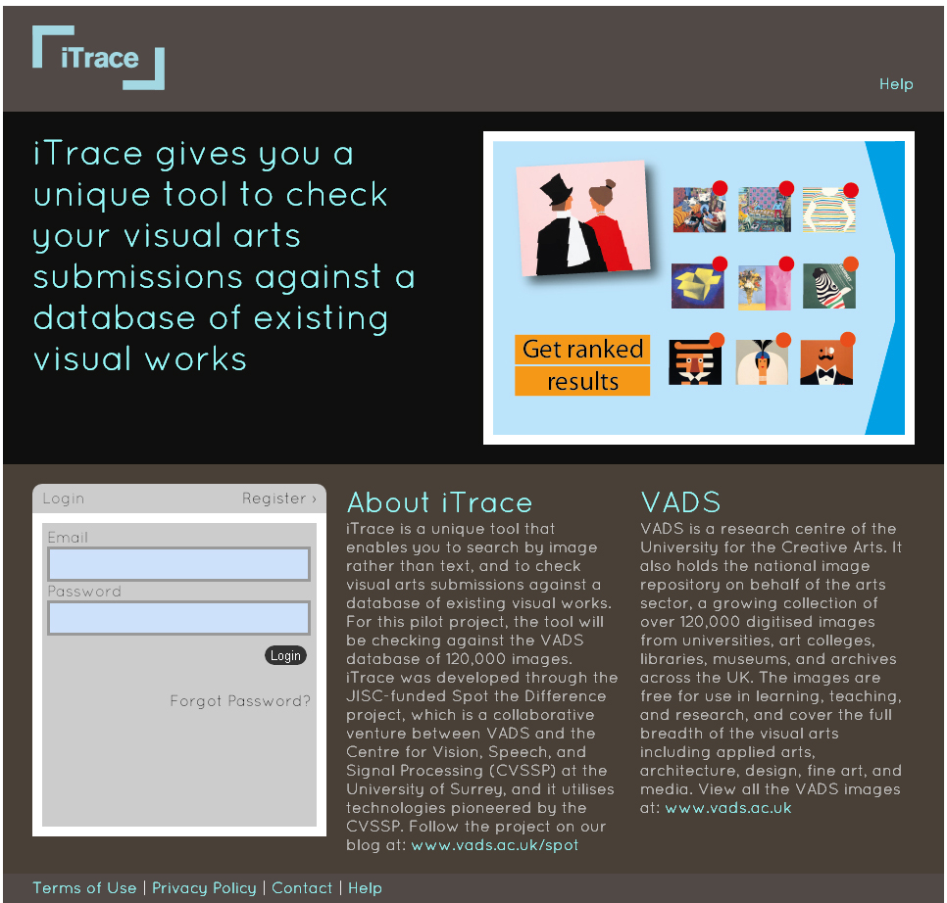
Fig. 2 iTrace homepage (top right: visual slideshow providing step-by-step guide to using iTrace).

Registration

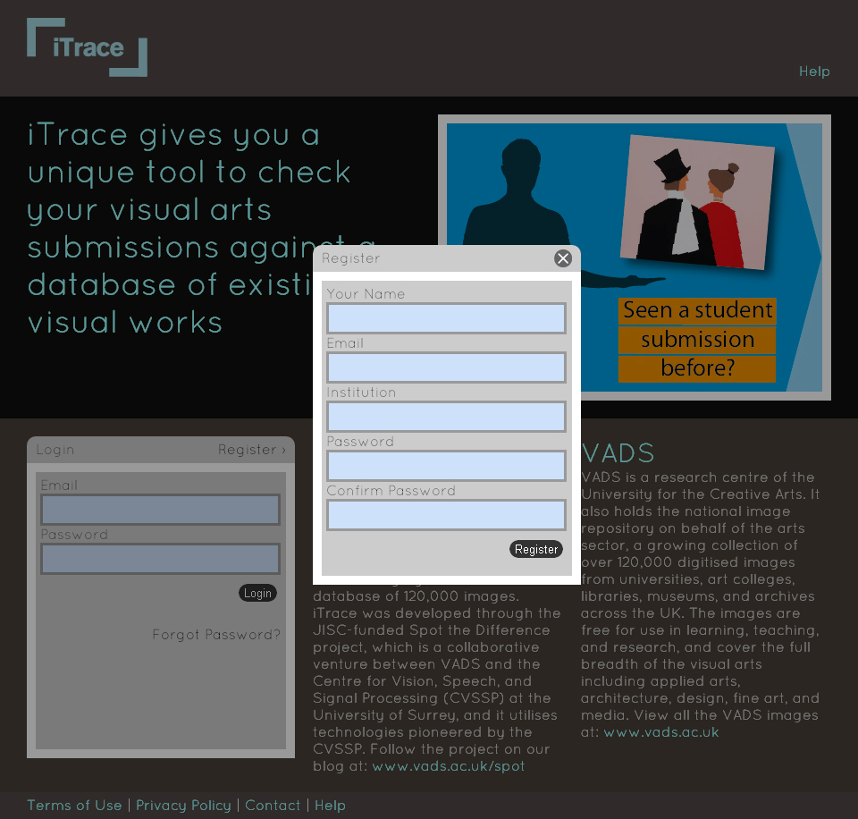
Fig. 3 Registration for login and password (to enable ‘saved searches’ and prevent spamming).

Uploading

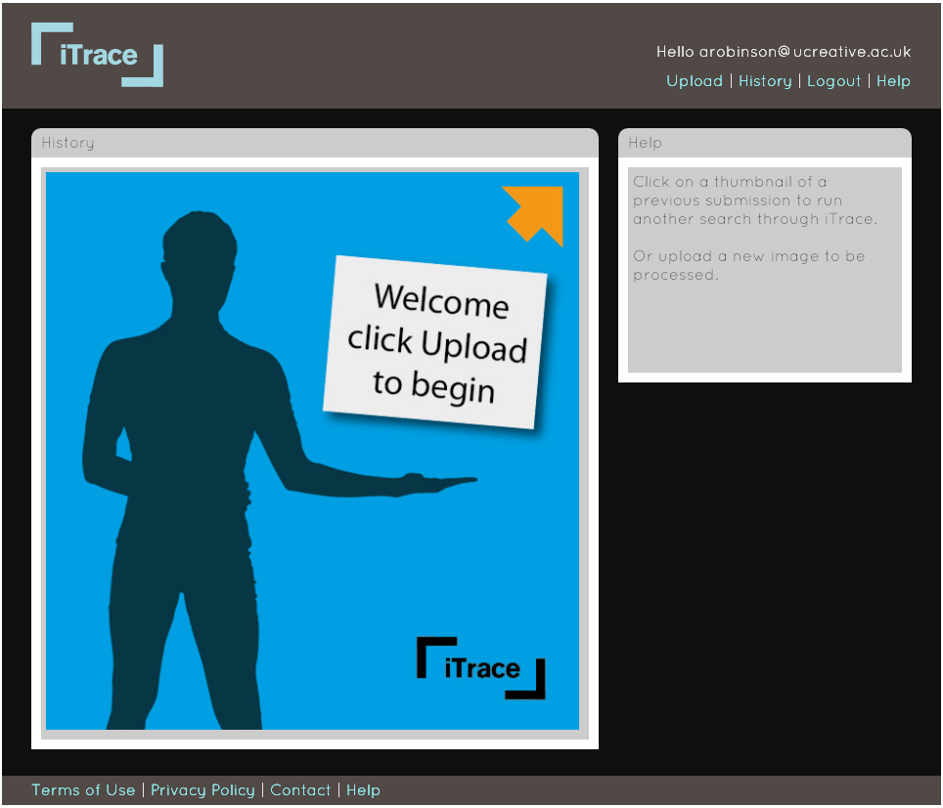
Fig. 4 Image upload screen.

Search Results

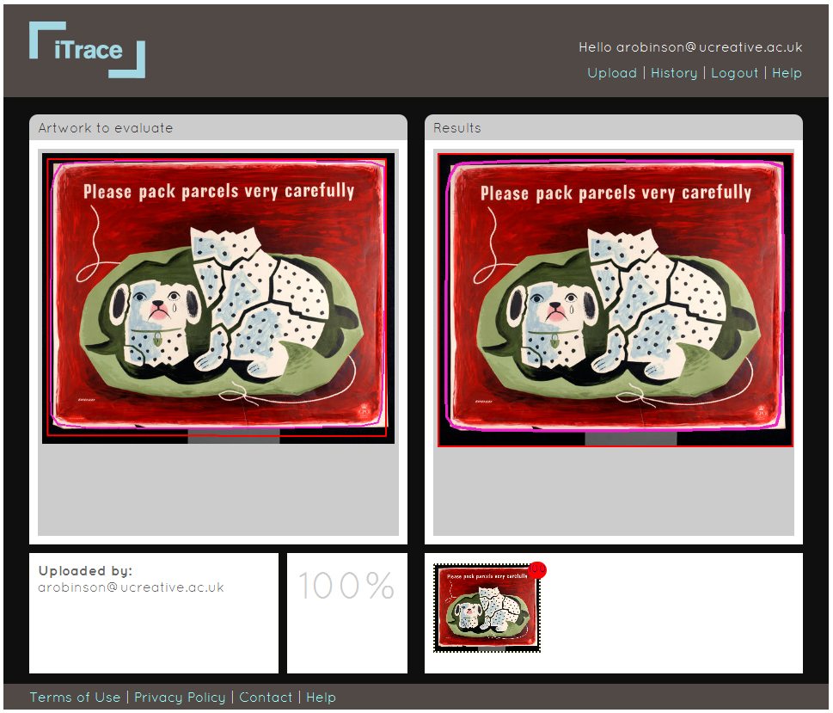
Fig. 5 Search results screen (left: uploaded image; right: search results drawn from an index of VADS images and from any images previously uploaded to iTrace; click on right hand image to link through to the relevant metadata record on the VADS website).

History

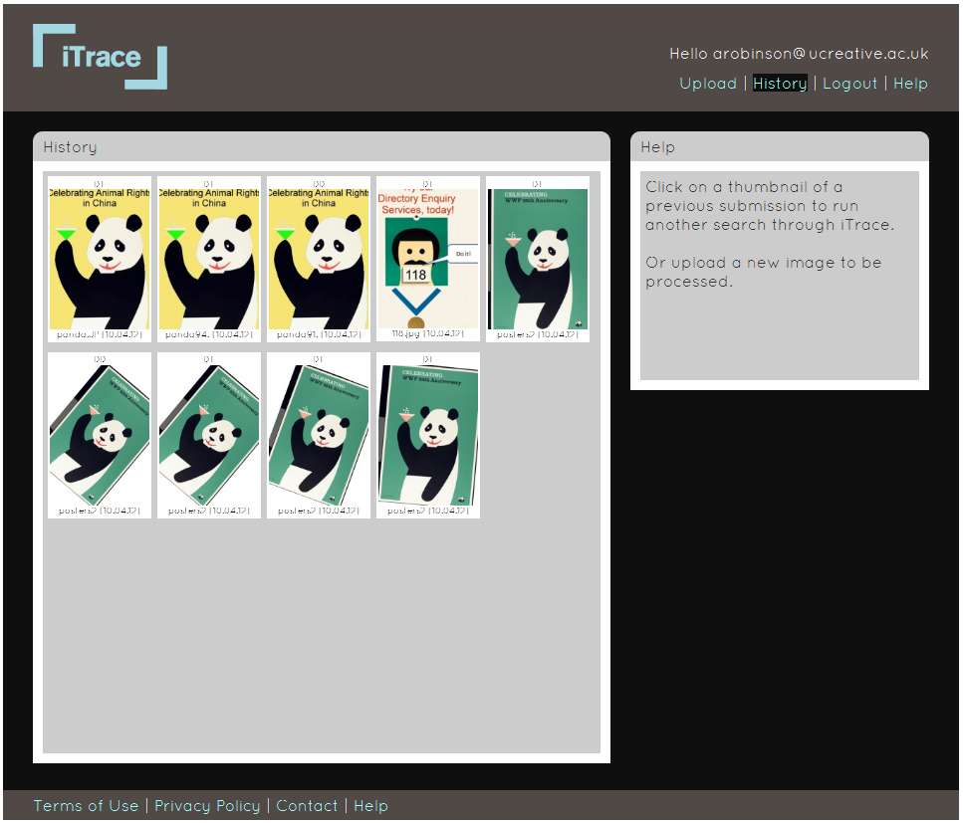
Fig. 6 History screen (click on a thumbnail to run a previous search through iTrace).

Help

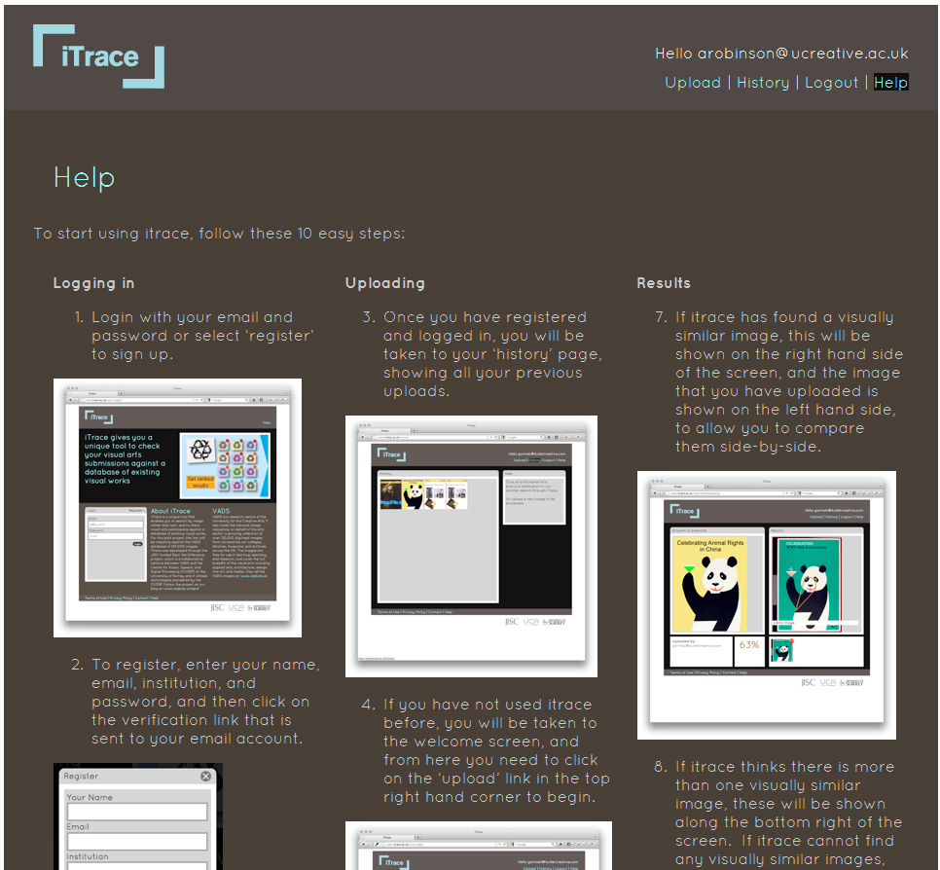
Fig. 7 Help page with guidance on how to use iTrace.

Project Management

  - Face-to-face team meetings were held monthly between the team at UCA, Surrey, and Bullet Creative, and Skype meetings were held weekly whilst rapid technical development was underway in order to communicate and solve bugs quickly. Google Docs was also used to track progress on technical development.

  - A consortium agreement and project plan were drawn up at the outset of the project using the JISC templates, and project progress was detailed midway in an interim report to JISC.

User Testing

  - The project team held three user testing workshops in January and February 2012 at three specialist arts institutions to gather feedback on the pilot iTrace tool, from a total of 32 staff and students at: Arts University College at Bournemouth; University of the Arts London; and University College Falmouth.

  - A range of higher education experience was represented across these pilot groups, including academic and support staff as well as students at undergraduate and Postgraduate Certificate of Education (PGCE) level, with a breadth of disciplinary expertise ranging from graphic design to performing arts and from textiles to photography.

  - The workshops included an introductory presentation on the project aims, findings, and technical development work so far. The participants were then shown how to register and upload an image to iTrace, and were invited to make their own image manipulations to test the accuracy of the pilot tool. Verbal feedback was sought on the applicability and usability of iTrace within arts education and discussion was minuted anonymously.

  - In response to workshop feedback (and where feasible within the timescale and resources of the pilot project) further technical development was then undertaken to further enhance the functionality of iTrace. For example, a ‘draft’ uploads feature was also added, to enable users to run a search on an image without submitting that draft to the database itself. Enhancements were also made after the first workshop in order to increase the speed of the searches.

Dissemination

  - In addition to the workshops themselves, the project was also disseminated at the following national events: the pre-conference Activity Week for the JISC e-Learning Conference (Nov 2011); the Art, Design, and Media Higher Education Academy (ADM-HEA) Creative Learning and Teaching Day (Nov 2011); and the Society of College, National, and University Libraries (SCONUL) Conference at the British Library (Dec 2011).

  - The project is also featured in a forthcoming journal article by the Project Manager in the Art Libraries Journal (Jun 2012).

  - The Project Manager was approached and interviewed by ‘IdeasTap’, a UK-based creative network and funding body for young creatives, for an online article on the topic of plagiarism in the creative arts (Nov 2011): www.ideastap.com/IdeasMag/all-articles/plagiarism-the-lowdown

  - The project was disseminated internally in a presentation at UCA’s Learning and Teaching Conference (Jan 2012); and at internal committees including the UCA Academic Integrity Board, Faculty Librarians Operational Team, and Library Collections Working Group. A press release was made available on the UCA website and intranet (Jun 2011).

  - Papers have been accepted for presentation at the Electronic Visualisation and the Arts (EVA) Conference at the British Computer Society in London (Jul 2012), and the International Plagiarism Conference at the Sage in Newcastle (Jul 2012). A conference abstract has also been submitted for the Association for Learning Technology Conference (ALT-C) at University of Manchester (Sep 2012).

  - The project has also been disseminated via the project blog (www.vads.ac.uk/spot).

.What did you learn?

Complex and nebulous concept of ‘visual plagiarism’

  - The literature review, survey findings, and interviews with staff underlined the ‘grey area’ surrounding the notion of ‘plagiarism’ in the visual arts and that it is a much more complex and nebulous concept than its text-based equivalent.

  - Staff emphasised the importance of copying as a learning strategy and survey respondents stated that ‘the history of training within the visual arts is one of “trying on others' shoes”‘ and asked ‘What are the visual arts equivalents for instance of a music student practicing works by famous composers?’.

  - The artistic practices of appropriation, homage, and pastiche were also frequently cited. Respondents stated that: ‘re-appropriation of existing work is a predominant feature of post modernism’ and ‘I think this is a very debatable area to get into as it depends upon definitions and contexts around the concept of originality’ and ‘”borrowing” the work of others is an accepted art practice (appropriation, recycling) and has a long history in art and photography.’ Plagiarism is ‘more difficult to define where a student is making something rather than a straight “essay”’ and ‘at what point does a 'style' or 'homage' become plagiarism?’

Focus on formative learning

- The most common reason for visual plagiarism to occur was cited as student misunderstanding (67% of survey respondents) and a formative and preventative approach was therefore seen as the most effective method of tackling plagiarism in the arts. This misunderstanding may occur, for example, because of cultural differences with different levels of acceptability in different countries (noted by 28% of survey respondents). As one respondent stated, the focus should be ‘on teaching students what they need to know rather than policing.’

- Learning activities have been developed in the higher arts education sector to ensure students understand the nuances of copying, homage, and appropriation, and avoid visual plagiarism. For example, by asking students to debate and reflect on acceptable practice by looking at the winners of the Plagiarius Awards, an annual negative award that is made to the most blatant design imitations (Academy of Art University 2010); or the ‘mock trial’ event held by one survey respondent, which is a role play event in which students test and play out whether it is acceptable to copy in their subject specialism.

Developmental nature

- The developmental nature of learning and teaching in the arts is also felt to minimise the incidence of visual plagiarism. As one respondent stated, ‘regular tutorials ensures that I can see students’ work development’ and ‘students also show development of their ideas and technique in workbooks.’

- However some respondents voiced concern that their close contact and observation of students work will become ‘more difficult with teaching larger numbers with less contact time as a result of efficiency gains (cuts)’ and ‘a University unwilling to put forward sanctions for anything that might jeopardise the students fees’ and the ‘growth of a factory model of education in HE.’

Images in presentations and written work

- A lack of referencing for images in presentations was identified as a particular concern with 46% of survey respondents stating that this occurs frequently, and 42% stating that a lack of referencing for images in written work occurs frequently, compared to just 6% of staff who felt that plagiarism in visual work was a frequent occurrence.

- Respondents felt that ‘there is a certain level of understanding about the correct way of referencing for written work, but these conventions are often ignored when dealing with visuals’ and that staff may not always set a good example as they ‘often don't reference their visual sources in their teaching presentations and therefore students don't see the importance of doing so,’. It was also felt that University referencing guidelines for non-traditional sources are less readily available.

- It was therefore felt by survey respondents and workshop participants that the pilot iTrace tool could serve a valuable function as an image reference checking system. Staff and students commented that they often have images on their computer but can’t remember where they found them or have trouble tracking down the correct source information.

Policies and procedures

- Several survey respondents noted a lack of institutional policies and procedures for visual-based plagiarism. One commented that ‘all of our existing plagiarism processes and procedures are designed for textual rather than visual materials’, and another stated that, ‘we have no policy on visual plagiarism, but as a team in photography we seem to have a consensus.’ It was also observed by one respondent that, ‘when plagiarism was detected - the institution had no clear policy on how to respond to the situation i.e. opportunities to address, punishment etc’ and another mentioned that they are currently ‘developing clear guidance on how to avoid.’

Internet copyists and Internet detectives

  - According to the survey responses, the most common source of plagiarised visual work is visual media copied from the Internet (49%), with lesser numbers copied from published sources, or from exhibitions, or from other students’ visual work, or by self-plagiarising.

  - Several dedicated ‘name and shame’ websites have also arisen in recent years where users can post and debate suspected cases of visual plagiarism, such as the website youthoughtwewouldntnotice.com and the Facebook group ‘Designers and Illustrators Against Plagiarism.’

Digital image manipulations

  - To test the accuracy of the iTrace pilot, workshop participants conducted a variety of manipulations to the VADS images. The manipulations which iTrace successfully matched to the original images included: blurring, cropping, rotating, painting over the top of an image, removing parts of an image, and combining images. See below for some examples from the project workshops:

Cropping an Image

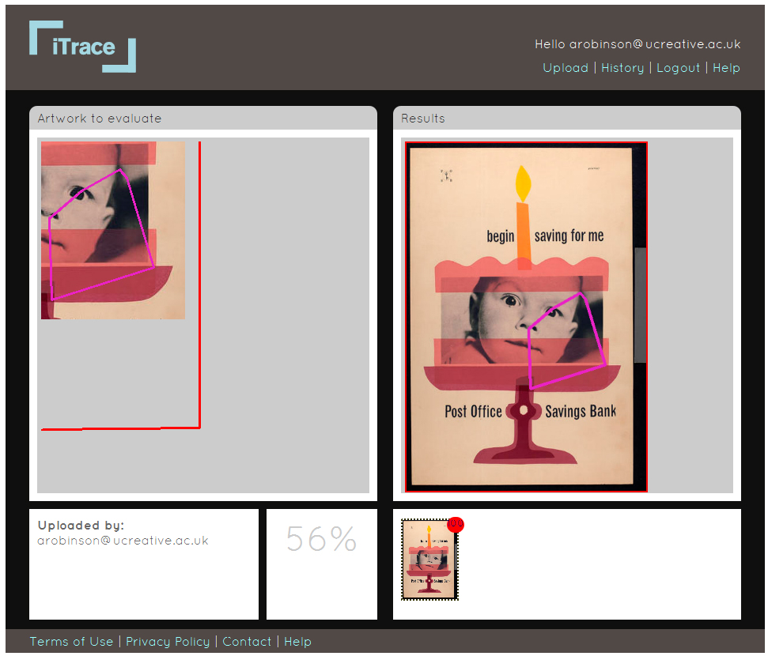
Fig. 8 Search results screen (left: cropped image; right: matching search result).

Painting over an Image

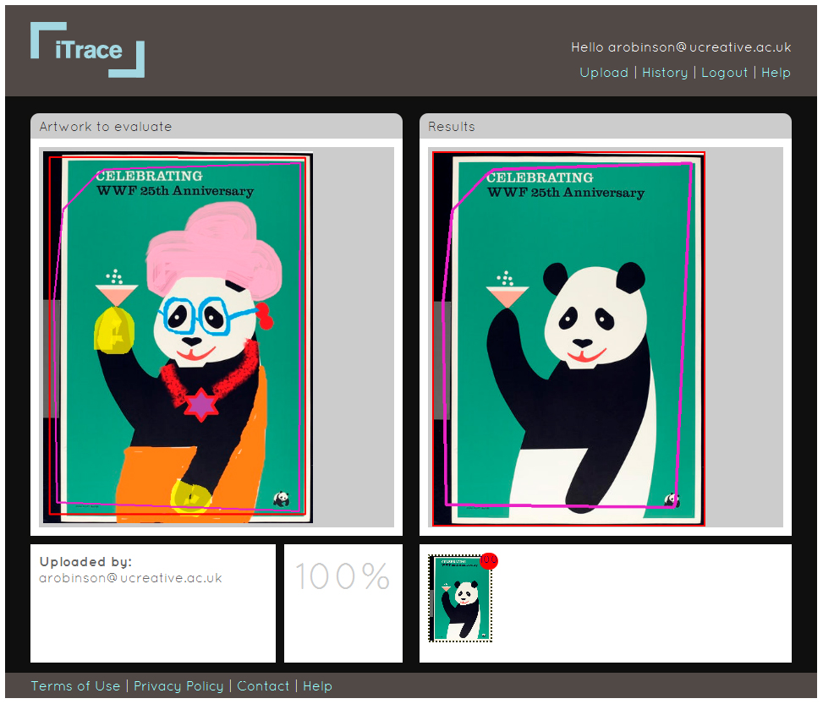
Fig. 9 Search results screen (left: painting over an image; right: matching search result).

Rotating and Combining Two Images

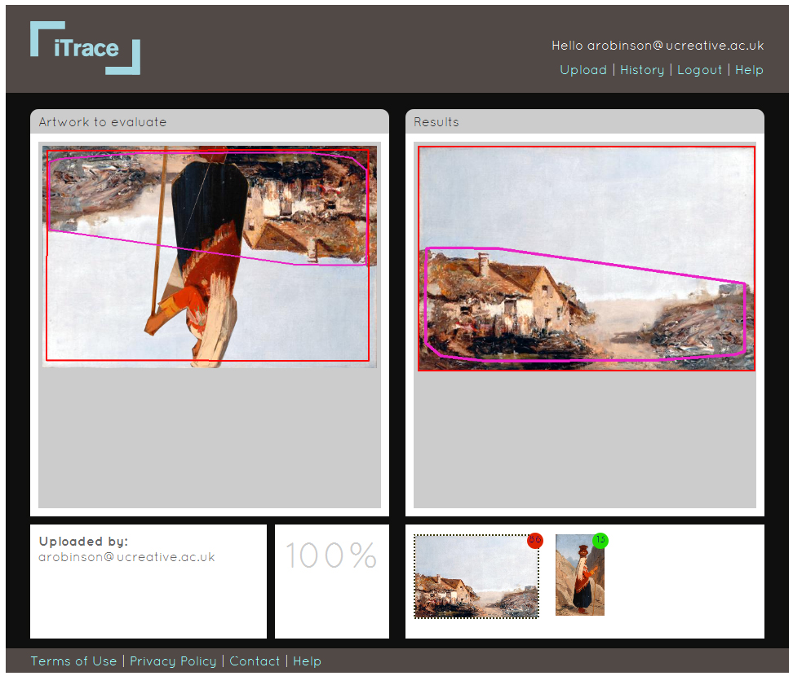
Fig. 10 Search results screen (left: combination of two images rotated 180º; right: matching search results).

  - Certain manipulations weren’t successfully matched to the originals, for example, when the orientation was inverted, the image was turned into a negative image or polka dot image, or the manipulation was very significant.

Additional Applications of iTrace

  - Some participants could also see the potential of iTrace being used ‘the other way round’ to track usage of their own staff work and usage of student work and to measure its impact, or to protect their Intellectual Property Rights (IPR). As one survey respondent stated, ‘it is a topic of great interest amongst students - they are also concerned that their own work is not plagiarised - images/film/photos etc.‘

- Some workshop participants could also see the potential for iTrace to be used as a search tool, and commented that it seemed better than Retrievr (http://labs.systemone.at/retrievr) in that respect. Another participant felt that it could be used as a reference for finding what other artists’ work looks like their work.

Cloud-based Service

  - One of the outcomes of this project for the CVSSP at University of Surrey is evidence that deploying a visual search system of this kind in a cloud architecture is a feasible proposal.

Immediate Impact

- The Spot the Difference project has enhanced staff and students’ understanding and awareness of the nature and issues around visual plagiarism, a topic which many conceded had received little attention at their institution. Both workshop participants and survey respondents pointed out that visual plagiarism isn’t discussed and stated that, ‘there seems to be a general lack of knowledge’ and ‘I don't believe that it is ever formally addressed in studio practice for design or fine art’ and ‘needs debate and open discussion.’ Others stated that ‘awareness is limited in my experience…I believe an awareness campaign for members of staff would be valuable’ and ‘more education is required to warn of the hazards’ and ‘the issue needs to be given far higher profile in teaching time’ and ‘I think this is a really useful project and potentially very beneficial.’

- The project blog has been cited in Library guides, workshops, and articles by the wider sector. For example, the University of the Arts London’s ‘Advice on Using Images in Teaching and Learning’ Guide and the ‘Using Images’ Guide at Newcastle University, and a workshop on images by Newcastle University Library. The project blog and the iTrace pilot will be further promoted as information and learning resources to the wider sector through the JISC Embedding Benefits Programme project in May-September 2012.

- The project has developed the team’s knowledge and expertise on the topic of visual plagiarism and the potential application of visual search technology in this area. Conference paper applications to ALT-C, EVA, and the International Plagiarism Conference have been accepted, and the Project Manager has also been successful in an application to the UCA Promising Researcher Fund in relation to their work at VADS and the project.

Future Impact

Further user testing and feedback from the UK education sector will be gathered through the JISC Embedding Benefits Programme project in May-September 2012.

Conclusions

The concept of ‘plagiarism’ in the visual arts is a complex ‘grey area’, and respondents felt that it was best addressed through learning activities and open discussion with students on the nuances of copying, homage, and appropriation, and associated legal issues, and through ongoing monitoring and feedback on the development of student work in sketchbooks, workbooks, and course blogs. A number of participants in this project also conceded that it is not, however, an issue that is discussed and that institutional policy tends to focus on textual rather than visual materials. As one participant commented, the project has ‘opened up discussion about plagiarism and what this means in a visual and performative context…we would also be keen to be involved in any other projects of this nature, possibly including our performance colleagues.’ The project has also uncovered interest in using visual search technology in learning and teaching in the arts for monitoring the impact of visual work, IPR protection, reference checking, and visual searching, which could also be further investigated.

Recommendations

  - See new development work listed in section 6 below.

Implications for the future

New Development Work

- Increasing the size of the image index to include other visual sources in addition to VADS was felt by staff and students to be the most important requirement for the future development of the iTrace system.

- Workshop participants also recommended expanding the range of image formats that can be uploaded to the iTrace system, specifically to include PSD format as their students submit work in this format. Similarly, in the project survey, 25 different file formats were identified that are used for students’ visual arts submissions across the UK arts Higher and Further Education sector, such as TIFF, JPEG, PDF, PSD, RAW, and Quicktime, amongst others.

- Further research and development should be conducted into the image manipulations which didn’t successfully retrieve matched results using iTrace, such as inverted images and negative images.

- Workshop participants suggested that the ‘history’ or ‘administration’ section would need further enhancement to enable users to be able to organise their uploaded files into folders once they start to use iTrace heavily and begin to upload a large number of files.

Sustainability of Project Outputs

- The iTrace pilot (www.itrace.ac.uk) will be hosted and managed by the CVSSP at University of Surrey, and the project blog (www.vads.ac.uk/spot) will be hosted and managed by VADS at the University for the Creative Arts, for at least three years beyond the end of the project funding date, as per the terms and conditions of JISC funding.

Contact

- Leigh Garrett, Principle Investigator, lgarrett@ucreative.ac.uk
- Dr John Collomosse, Co-Investigator, J.Collomosse@surrey.ac.uk
- Amy Robinson, Project Manager, arobinson@ucreative.ac.uk

References

Academy of Art University (2010). Teaching tip: refining your teaching - visual plagiarism. At: http://faculty.academyart.edu/resource/tips/1768.html (Accessed on 22.05.12)

Blythman, M., Orr, S. and Mullin, J. (2007). Reaching a consensus: plagiarism in non-text based media. At: http://www.arts.ac.uk/induction/sites/default/files/resource/2010/09/plagiarism-non-tesxt-based-media-casestudy.pdf (Accessed on 22.05.12)

Correll, G. (s.d.). Designers and Illustrators Against Plagiarism. At: http://www.facebook.com/pages/Designers-and-Illustrators-Against-Plagiarism/190313407647321 (Accessed on 22.05.12)

Newcastle University (s.d.). Using Images. At: http://libguides.ncl.ac.uk/content.php?pid=312538&sid=2558333 (Accessed on 22.05.12)

Roberts, C. (2011). Plagiarism: the lowdown. At: http://www.ideastap.com/IdeasMag/all-articles/plagiarism-the-lowdown (Accessed on 22.05.12)

University of the Arts London (s.d.). Advice on Using Images in Teaching and Learning.
At: http://www.arts.ac.uk/library/images/copyright/ (Accessed on 22.05.12)

You Thought We Wouldn’t Notice (s.d.).
At: http://youthoughtwewouldntnotice.com/blog3/ (Accessed on 22.05.12)

Image Credits

The iTrace screenshots show a number of images from VADS, which are credited below:

Fig. 1. Studio of Albani, Francesco. (about 1650-1660). Faith, Hope and Charity [Painting]
At: http://vads.ac.uk/large.php?uid=91599 (Accessed on 22.05.2012)

Figs. 2, 3, & 4. Various images from the Tom Eckersley Collection and Tim Mara Collection
At: http://vads.ac.uk/collections/TEC (Accessed on 22.05.2012)
At: http://vads.ac.uk/collections/TM (Accessed on 22.05.2012)

Fig. 5. Eckersley, Tom. (c1940s). ‘Please pack parcels very carefully’, dog [Poster]
At: http://vads.ac.uk/large.php?uid=92509 (Accessed on 22.05.2012)

Fig. 8. Eckersley, Tom. [Poster]
At: http://vads.ac.uk/large.php?uid=115917 (Accessed on 22.05.2012)

Fig. 9. Eckersley, Tom. (1986). WWF [Worldwide Wildlife Fund] [Poster]
At: http://vads.ac.uk/large.php?uid=92477 (Accessed on 22.05.2012)

Fig. 10. French School. (probably about 1840-1850). Peasant Woman [Painting]
At: http://vads.ac.uk/large.php?uid=89337 (Accessed on 22.05.2012)

Fig. 10 Bowes, Joséphine. (about 1865-1870). Sketch of Cottages near Boulogne-sur-Mer [Painting]
At: http://vads.ac.uk/large.php?uid=89450 (Accessed on 22.05.2012)

