Celebrating fifty years of fashion:
The Zandra Rhodes Digital Study Collection project
(Jisc eContent programme 2011-2013 http://bit.ly/117nPaj)


Figure 1 Zandra Rhodes,
photograph by UCA Photography student Martin Gardner.

Author:
Amy Robinson, Project Manager

Institutions:
University for the Creative Arts (UCA)
Zandra Rhodes Studio

Zandra Rhodes Digital Study Collection:
zandrarhodes.ucreative.ac.uk

1. Doyenne of British fashion: what the experts say

“Zandra Rhodes is a superb fashion designer, textile creator and educator. Her taste level and colour sense are superb. She draws beautifully. Students all over the world would benefit from studying her digitised work.” - Gladys Perint Palmer, Executive Director, Fashion, Academy of Art University, San Francisco

“Zandra Rhodes is one of the most important British designers in fashion and textiles, a visionary of the 20th and 21st centuries…each image enables the detailed study of garments…and her introduction to the value of sketchbooks is one of the most significant contributions to this archive. Each page resonates with her fluency of line and confident shape making. Every observation reveals an insight into her world, mapping her travels and recording her experiences with a resolute commitment to drawing.” - Linda Brassington, Sessional Lecturer, BA (Hons) Textiles for Fashion and Interiors, UCA

“The Zandra Rhodes Digital Study Collection provides an in-depth insight into the world of one of the UK’s most successful and creative fashion designers. It is not only aspirational but it will allow academics and fashion design students to learn and discover printing techniques and start-to-finish methods of working that will allow them to develop their own creative skills in order to navigate and excel in the fashion industry.” - Professor Bruce Montgomery, Professor in Design Craftsmanship, Northumbria University
Zandra Rhodes is one of the most famous names in the British fashion industry over the last fifty years. She has designed garments for a host of eminent clients from royalty to rock stars, including elegant dresses for Diana, Princess of Wales, and flamboyant stage costume for Freddie Mercury.

Influenced by her training and passion for textile design, she is renowned for bringing an innovative approach to garment construction by using her bold and vivid screen print designs to determine the cut and shape of the garment. Other experimental techniques include her use of exposed seams, slashed garments inspired by Elizabethan silks, and her fusion of punk fashion with haute couture.

2. Silver trunks of treasure

In her studio space and apartment above the Fashion and Textile Museum in London, the designer holds a vast personal archive of many thousands of samples of garments that she has designed from the late 1960s to the present day, stored in vast silver trunks. Other creations such as her sketchbooks, artworks, printing screens, and koda traces have also been retained dating from her very earliest collections, making it a uniquely comprehensive record of her prolific career.

This unparalleled personal archive is completely inaccessible to the outside world except for selected designs which may be shown from time to time in temporary exhibitions, and its full potential use remains untapped.

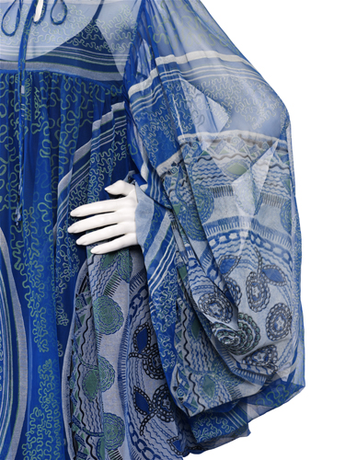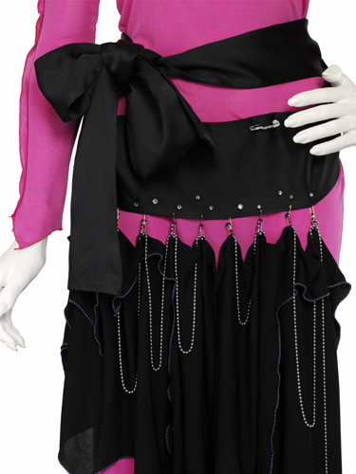
Figures 2 & 3 Details from her first collection The Knitted Circle, 1969, and from The Conceptual Chic Collection, which blends punk influences with couture, 1977-8 © Zandra Rhodes 2012, photographs by Jon Stokes.

3. Inspiring the next generation

The Zandra Rhodes Digital Study Collection project set out to open up this valuable resource online for use in learning, teaching, and research internationally, by fashion historians, fashion and textile designers, and fans of Zandra Rhodes work alike. It sought to digitally photograph and provide online access to a selection of 500 garments, and to research these pieces, and to provide detailed, searchable metadata. In order to enrich this Digital Study Collection further, the project aimed to develop an Open Educational Resource (OER) that focuses in-depth on 25 iconic garments, with accompanying primary and secondary source material in digital format.

This endeavour has been undertaken by researchers and students from the University for the Creative Arts (UCA), in collaboration with Zandra Rhodes Studio. Zandra’s relationship with the University dates back to her roots in Chatham, where she spent her formative years studying at the nearby Medway College of Design, now the Rochester campus of UCA. She became the University’s first Chancellor in 2010.

The project has set out to provide the next generation of fashion and textile design students from the University’s BA courses with valuable work experience behind-the-scenes at the prestigious Zandra Rhodes fashion house, through paid internships with the project team, to support the preparation, photography, and documentation of these exquisite vintage pieces.

4. Digital curation in the fashion studio

4.1 Prep days and ‘restoring their natural beauty’
The designer’s collection totals an estimated 7000 garments held in chests lining the walls of the studio from the floor to the ceiling, as well as under the screen printing table in the basement, and upstairs in the designer’s apartment. Packed full of clothing with intricate detailing, layering, and delicate silk chiffon, there was an inevitable and meticulous task of pressing many of the garments after several years in storage.

This careful preparation proved to be a lengthier process than photographing the garments, and so dedicated ‘prep days’ were introduced between each photo shoot. This allowed for the manoeuvring of heavy trunks, unpacking, selecting, pressing, pairing outfits, gathering information, and packing away garments, as well as for minor repairs to be made to a handful of items.

The archive was uncatalogued and so there was an exciting serendipity to the team’s work, aided by an existing box listing which often read simply, ‘mixture of historical and modern’, as well as tantalising labels on some of the trunks such as ‘Punk/Mexican.’

4.2 Cataloguing a lifetime of design
On the first visit to the studio, the designer introduced the team to the ‘Zandra Rhodes Style Bibles’, which chronologically record her fashion collections as a series of drawings since 1969. This private working resource, unseen to the outside world, became a vital starting point for the project’s metadata.

The drawings in the ‘Style Bibles’ helped us to verify the season and collection name for each of the garments, and a separate ‘Textile Design Bible’ was used to identify the name of the print design. Each of the drawings has a unique ‘Zandra Rhodes Style Number’, which usefully provided the project with a digital image filenaming convention. This information was recorded on a paper form and attached to the garment’s hanger, to stay with it throughout the project workflow in different areas of the studio.

Additional information was researched and recorded by the project’s Digital Cataloguer, Marie-Therese Gramstadt, such as the colourway, object type, techniques and fabrics used, and notes on who wore an item and any other special characteristics. The metadata schema was informed by looking at existing subject-based standards and controlled vocabularies were also established for documenting key features.

The identification and cataloguing of the garments was enhanced by having our very own ‘living bible’ in the form of the studio’s Production Manager, Frances Diplock, with her extensive knowledge of the collections, having worked with the designer since 1976. For example, she has recounted several high points from the garments’ past, from a pleated jacket worn by Princess Margaret, Elizabeth Taylor, and Joan Collins, to a jumpsuit worn by the character Margo in an episode of ‘The Good Life.’

4.3 Photographing in situ
An area was temporarily allocated for the project photography at one end of the textile print design room. This room stretches like a deep aladdin’s cave filled with paint pots, trunks, books, drawings, and assorted treasures in every space and this is where Zandra Rhodes and her staff busily work on their latest print designs.

The garments were dressed on a mannequin by the project interns and checked by the studio’s Production Manager. This styling often meant locating matching slips and sashes, swapping for a smaller mannequin, pinning the garment to keep it flat, or adding padding or fish wire to give it shape.

The project had to balance the need for high image quality, consistency, and productivity to meet the target of 500 garments, whilst working within a minimal shooting area and not disrupting the day-to-day work of the studio team.

The photographic set-up was adapted in various ways to accommodate these requirements and environment. For example, in order to remove the background and to give the final images a clean and cohesive look, the photographs were sent to an external company where a clipping path was used to add a pure white background. In addition, to speed up the workflow, the Photographer Jon Stokes set up two digital medium format cameras. One was to stay in the same position for three shots of the overall garment from the front, back and side, and another camera could be moved around for taking a fourth, detail shot. Markers were also placed on the floor to ensure the mannequin was positioned consistently for each shot.

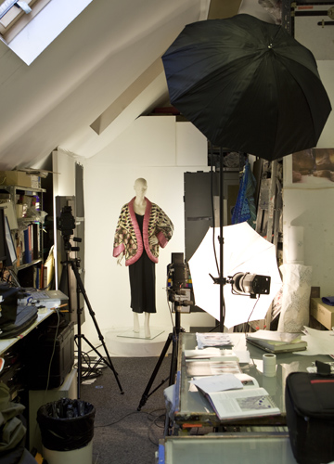
Figure 4 Photographic space at Zandra Rhodes Studio,
photograph by Jon Stokes.
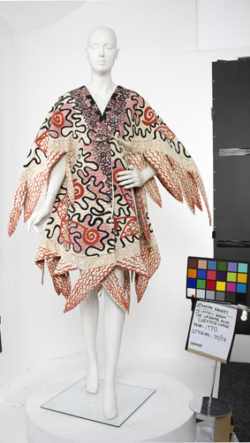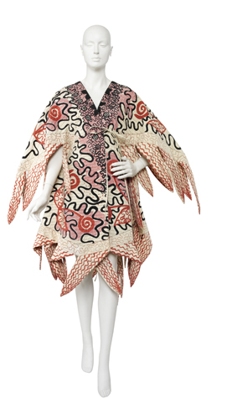
Figures 5 & 6 Coat from The Ukraine and ‘Chevron Shawl’, 1970.
Left: before adding clipping path. Right: after adding clipping path,
© Zandra Rhodes 2012, photograph by Jon Stokes.

4.4 Opening up the ‘Style Bibles’
As well as providing the project with key metadata, the ‘Zandra Rhodes Style Bibles’ were recognised by the project team as a valuable primary research resource for digitisation. Since the bibles were relatively easy to digitise, and the specialist staff and equipment for scanning had recently been established at the University Library’s Digitisation Unit, the project has been able to comprehensively digitise every page of these beautifully stylised fashion drawings.

The bibles are an irreplaceable working resource that couldn’t leave the studio, and therefore a scanner was transported to London by Polly Christie and Lisa Chadwick from the Digitisation Unit, who scanned for two days onsite to produce images of over 1000 pages.

Users will be able to leaf through the collections year-by-year using ‘Turning the Pages’ software at: http://www.zandrarhodes.ucreative.ac.uk/p/drawings.html
An internship opportunity was also offered for a Master of Fine Arts (MFA) Photography student to assist with the digital post-production of the bibles and their delivery online using ‘Turning the Pages’.

In addition, the relevant drawings have been added to the Visual Arts Data Service (VADS) website to put them in context with the 500 photographed garments: http://www.vads.ac.uk/collections/ZR

The ‘Style Bible’ drawings have also been used to illustrate the project’s video interviews with the designer: http://zandrarhodes.ucreative.ac.uk/p/ask-zandra.html

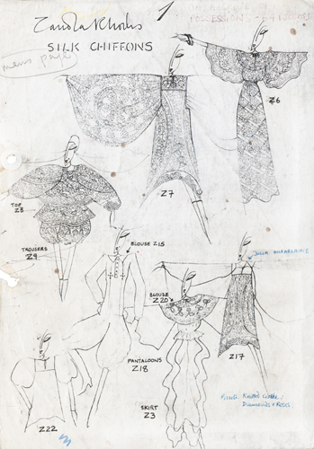
Figures 7 & 8 kaftan from The Knitted Circle, 1969, with its corresponding ‘Style Bible’ page. 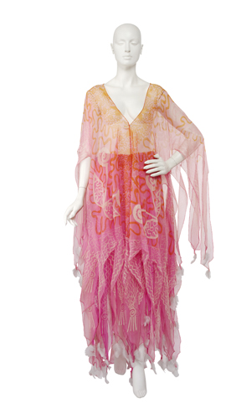 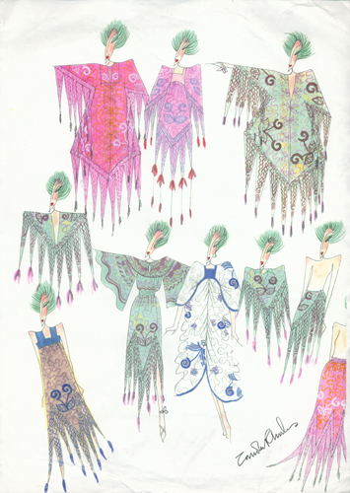
Figures 9 & 10 ensemble from The Ukraine and ‘Chevron Shawl’, 1970, with corresponding watercolour.
© Zandra Rhodes 2012, garment photographs by Jon Stokes.

5. Asking our audience

Academic input on the next stage of the project and the creation of the OER was gathered through a series of one-to-one interviews with twelve members of academic staff from across the UCA fashion and textiles courses at the Epsom, Farnham, and Rochester campuses. This included course leaders, teaching and sessional staff, and the Head of the School of Fashion. An OER focus group was also held with fashion and textiles academics from across several UK universities, to engage with the wider Higher Education community and seek their input. Another focus group was held with the project’s student interns. This consultation with a range of potential users has informed the project methodology in the following key ways:

5.1 Digital representation of fashion and textiles
Academic staff pointed out that it is vital to provide multiple image views and for textiles students to be able to home in and see the details of the fabrics. This validated the project’s existing approach to the photography, with the garments captured from four different views, and the project’s use of ‘Zoomifier’ for the 500 couture pieces on the VADS site. The functionality, navigation, and appearance of the VADS site was enhanced further in response to student testing and feedback, for example, the ‘zoom’ feature was moved to make it more prominent and simple radio buttons were added to make the search options clearer.

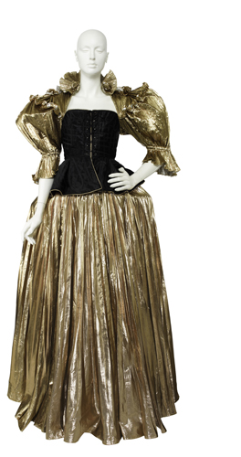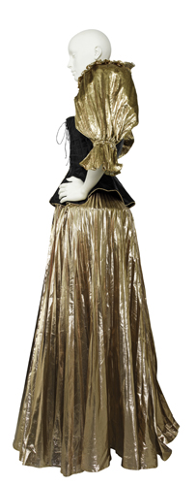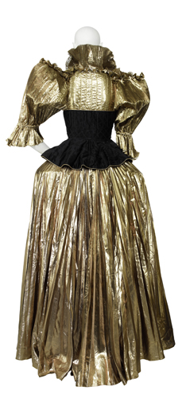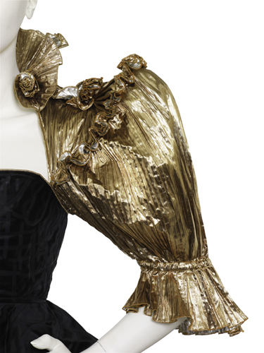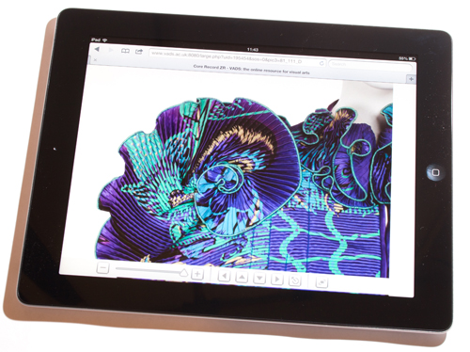
Figs 11-14 Front, side, back, and detail view from The Renaissance/Gold Collection, 1981.
Figure 15 Detail view of jacket from The Africa Collection, 1981, viewed on the VADS test website using a tablet computer © Zandra Rhodes 2012, photographs by Jon Stokes.

5.2 Video tutorials
The UCA Learning Technologist, Tony Reeves, suggested creating a series of video tutorials to demonstrate the specialist Zandra Rhodes Studio production processes. Technical instructional videos have already been used to support learning and teaching at UCA, for example, video tutorials have been created by the Fine Art and Textiles courses at Farnham, and also by UCA’s partner institution, the Royal School of Needlework. These videos enable students to be able to see the details, pause and rewind, and watch the demonstration as many times as required, and may be particularly useful for students whose first language isn’t English, or for those with certain learning disabilities.

The project has developed ten video clips with the expert staff at Zandra Rhodes Studio demonstrating and explaining the processes of creating a quintessentially handcrafted Zandra Rhodes garment, such as her characteristic technique of using the print design to inform the garment’s shape: http://zandrarhodes.ucreative.ac.uk/p/tutorials.html

This filming also provided additional work experience opportunities for two BA Film Production students.

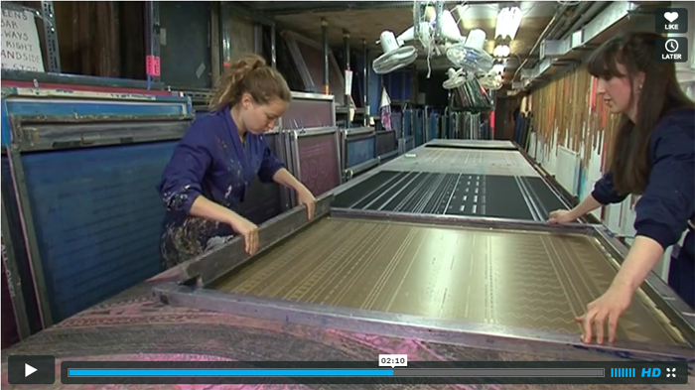

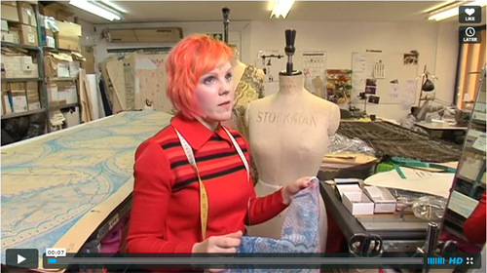
Figs 16 & 17 Stills from video tutorials with Caroline Carrig, Screen Printer,
and Michelle Lewis, Pattern Maker, at Zandra Rhodes Studio.

5.3 Pre-digital techniques and the sketchbook
Academic staff were interested in the studio’s use of pre-digital processes such as screen printing and drawing, and ensuring these skills aren’t lost, and were particularly interested in the designer’s use of sketchbooks, which she takes wherever she travels. Several staff mentioned a shift in how fashion students undertake their research with a greater use of digital photography. The project has therefore filmed an additional video with Zandra Rhodes discussing some of the fantastic, colourful examples from her collection of sketchbooks and how she uses these as part of the creative process: http://www.zandrarhodes.ucreative.ac.uk/p/tutorials.html

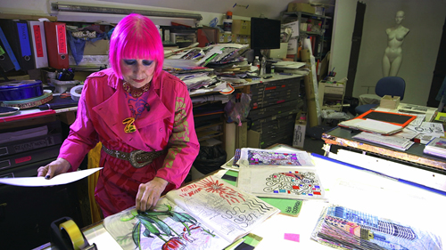
Figure 18 Still from video with Zandra Rhodes about her sketchbooks.

5.4 Inspiration and the ‘starting-point’
When asked if they only had one question to ask Zandra Rhodes, academic staff unanimously said they would like to ask her where she gets her inspiration, and to support students with this ‘starting point’. In response, the project has filmed an interview with Zandra Rhodes focusing predominantly on the inspiration behind her 25 favourite, iconic pieces. These interview clips reveal the way that her designs are influenced by her travels, world cultures, historic costume, museum collections, as well as everyday objects, nature, and the people and things that surround her, and her own past creations: http://zandrarhodes.ucreative.ac.uk/p/ask-zandra.html

5.5 In-depth case study approach
Academics were interested to see approximately 10 out of the 500 garments worked into detailed case studies with accompanying contextual material. This reaffirmed the project’s existing plans to focus in-depth on a selection of garments. The video interviews with Zandra Rhodes on these selected garments are accompanied by further text and hyperlinks to relevant sources, as well as images of the relevant drawings, watercolours, and finished pieces. This has been made available on a dedicated project website as well as via Vimeo for wider exposure and discovery.

5.6 Wearing the garments
As part of these case studies, academic staff would like to see photographs of people wearing the garments at the time. For instance, the V&A’s Kylie exhibition in 2007 was cited as a particularly popular exhibition because of the accompanying photographs of Kylie wearing the garments. Whilst the project has permission from Zandra Rhodes to make her archive available online, the use of these additional images requires permission and potentially fees from third party rights holders such as publishers and photographers. The project has therefore sought clearance for just a small selection of these images, namely from the 2012 Zandra Rhodes retrospective show at Paris Fashion Week. Hyperlinks were added to direct users to other examples, if available online elsewhere.

6. Lessons Learnt and Tips

6.1 Digitising private archives
Digitising this amazing private collection has brought both practical challenges and phenomenal opportunities. As described in section 4, it was a thrilling serendipitous process and great privilege to be the first researchers to sort through and catalogue a selection of this extensive collection. As described in section 4, issues of space and layout were alleviated with solutions such as prep days, clipping path ‘cut-outs’, and a paper catalogue form. A neighbouring room in the Fashion and Textiles Museum was also utilised temporarily for scanning the ‘Style Bibles’.

Students’ availability during the academic year as well as periods of high work load in the studio, such as Paris Fashion Week in February 2012, sometimes proved a challenge for co-ordinating the project rota and this was resolved by doing a concentrated period of digitisation throughout the summer months. The project also needed to ensure that communication was maintained with both the designer’s UK and US teams as she made regular fortnightly trips between the two offices.

6.2 The personal touch
By working with a private archive, the project has been rewarded with incredible hands-on involvement and behind-the-scenes insights from the designer and her team, unlike the conventional digitisation of artefacts in an impersonal white-walled museum or archive store, far removed from their original context and creator. This has greatly benefited the project’s research, selection, and styling of the garments, as well as the experience gained by student interns within a world renowned fashion house.

The project has also been able to film the studio’s creative processes and oral testimony from Zandra Rhodes about the inspiration and stories behind her most iconic and favourite garments (see sections 5.2, 5.3 and 5.4). This has helped to make the collection distinctly personal:

“…perhaps the most enriching element is the facility to go beyond the still image…while documenting her skill and in-depth knowledge of her subject, this resource is injected with her unique personality, creative energy and humour.” - Linda Brassington, Sessional Lecturer, BA (Hons) Textiles for Fashion and Interiors, UCA

6. 3 The student experience
Eleven students from across UCA Fashion and Textiles courses in Kent and Surrey have completed paid internships on the project, working alongside Zandra Rhodes and the project team at her studio in London. In the focus group, students were asked about what difference that the project has made to them, and students have also reflected on their experiences throughout the project via the blog at: zandrarhodesarchive.wordpress.com. A summary of their comments are below:

“Going through all her collections inspired me”
The students enjoyed working with the garments, learning about them and the history behind them, getting to see them close-up, to feel the different fabrics used, and to understand how the garments were constructed. For example, one student blogged about using images of the garments as research within their sketchbook.

“Seeing industry at work!”
The students gained an insight into the industry, and how a fashion studio is run, and learnt about the different roles in the studio, and saw the studio’s progress over the summer. They learnt about its techniques and processes and found it an inspirational environment.

“Gained skills and knowledge that I can take away with me”
Students also mentioned other skills, attributes, and knowledge gained, such as perseverance to achieve perfection, and learning about how a photoshoot is organised and what the photographer does. Four interns gained rare experience when the project was joined by camera crews and filmed working with Zandra Rhodes and interviewed for three television news features in July 2012 and March 2013.

“I felt privileged”
The students felt privileged to be working alongside Zandra Rhodes and to see her role in the studio. They felt appreciated and part of the team, and found that they had more responsibility than they initially thought, and that Zandra Rhodes had full trust in them with her garments. The interns also enjoyed undertaking a mixture of tasks from preparing garments to assisting the photographer.

“It built up my confidence”
The internship built confidence, and students felt it was a comfortable and friendly atmosphere.

“Shows future employers that I am willing to work hard”
The students felt that the internship will help them with securing future work experience placements and their future employability, and that it will demonstrate their passion for their field of study and a strong work ethic.

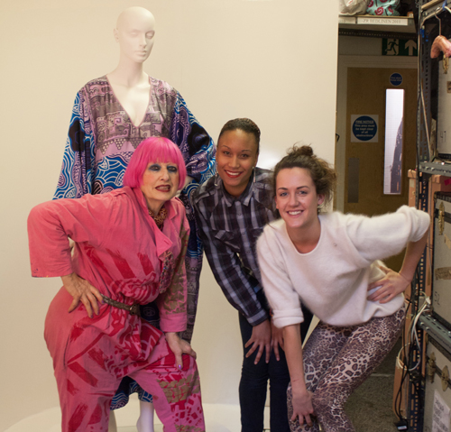
Figure 19 Zandra Rhodes in her studio with first year student interns, Rochelle Minors and Lauren Hunt, from BA Fashion Design at UCA Rochester.

6. 4 Harnessing student talent across the arts
There are numerous possibilities for involving creative arts students in a project of this kind. In addition to the planned internships for fashion and textiles students, further opportunities were identified for students from Film Production, Photography, and Journalism courses, as the project progressed. For example, in December 2012 the project invited students from the University’s photography courses to the Zandra Rhodes Studio to take portrait photographs of the designer for use on the project web pages, printed publicity, and University press releases (see fig. 1, pg. 1).

7. Launching the collection to the world

From the outset, the Zandra Rhodes Digital Study Collection project has been a high profile initiative. It was featured on the BBC News website and in BBC South East and ITV Meridian television reports in 2011 and 2012. The project team have presented their work through a number of forums, including Selvedge magazine, the Association of Dress Historians Research Day, the National Society for Education in Art and Design magazine, UCA Alumni magazine, as well as presentations at the University of Brighton, Ravensbourne, and Coventry University, and forthcoming presentations to the Art Libraries Society UK & Ireland.

An official launch event was held at the Fashion and Textiles Museum on 26 March 2013 and the Digital Study Collection was unveiled by actress Joanna Lumley, best known for her role in TV sitcom ‘Absolutely Fabulous’, in which Zandra Rhodes herself once made a guest appearance.

This provided another unique experience for student interns, with the BBC filming the day’s preparation with Fashion students, as well as a live broadcast at the event. Photography students documented the event and their photographs later featured in numerous press articles including Hello! Magazine.


Figure 20 Zandra Rhodes and Joanna Lumley at the launch event, UCA homepage, photograph by UCA student Hannah Kells.

8. Conclusions

The passion of the project team and generosity of the designer and her studio staff has meant that this project has gone far beyond its original objectives. A tremendous 500 vintage couture pieces from the Zandra Rhodes archive have been digitised to a high standard from multiple views and extensively catalogued from scratch and an OER has been developed focusing on the inspiration behind her iconic garments through exclusive video interviews with the designer. In addition, the project has developed video tutorials sharing key fashion and textile production processes in the studio, as well as fifteen online ‘Style Bibles’ totalling 1000 pages of every Zandra Rhodes fashion and textile design. The project has also provided work experience opportunities for eighteen UCA students.

With the support of the UCA Creative Fund, further filming has taken place at the Zandra Rhodes Studio in February 2013 on topics proposed by the academic focus group, including the designer’s collaborations with other businesses and tips on how to progress in the fashion industry. These additional videos will be launched online later in Spring/Summer 2013, and the team will continue to seek opportunities for disseminating, embedding, and enriching the online collection further beyond the end of this exciting project.

Project Director: Professor Kerstin Mey
Project Manager: Amy Robinson

Full credits for the team of staff and students behind this project at: http://www.zandrarhodes.ucreative.ac.uk/p/project-team.html

